# C:\Users\VidyaGxp User 2\AppData\Local\Microsoft\Windows\INetCache\Content.Word\logo.png

# Document Comparison Pro

Start - User Guide

## Table of Contents

1. **Introduction** .............................................................................................1  
   1.1 Overview .............................................................................................1  
   1.2 Key Features ........................................................................................1  
   1.3 Target Audience ..................................................................................2
2. **System Requirements** ..............................................................................2  
   2.1 Minimum Technical Requirements .....................................................2  
   2.2 Server Requirements (For Installation on Client Servers) ...................3
3. **Accessing Document Comparison Pro** ...................................................3  
   3.1 Logging In ...........................................................................................3  
   3.2 Forgot Password ..................................................................................4
4. **User Roles and Permissions** ....................................................................4  
   4.1 Overview .............................................................................................4  
   4.2 User Roles ...........................................................................................5  
   4.3 Managing Permissions ........................................................................5
5. **Uploading and Managing Documents** ...................................................5  
   5.1 Uploading Files ...................................................................................6  
   5.2 Supported File Formats .......................................................................6  
   5.3 Document Validation ...........................................................................7
6. **Performing Document Comparisons** .....................................................7  
   6.1 Comparing Documents ........................................................................7  
   6.2 Report Generation ...............................................................................8  
   6.3 Comparing Multiple Versions .............................................................8
7. **Viewing and Managing Reports** .............................................................9  
   7.1 Accessing Comparison Reports ...........................................................9  
   7.2 Sharing Reports .................................................................................10
8. **User Management (Admin Only)** .........................................................10  
   8.1 Adding New Users ............................................................................10  
   8.2 Editing User Permissions ..................................................................11
9. **Troubleshooting and Support** ..............................................................11  
   9.1 Common Issues .................................................................................11  
   9.2 Technical Support ..............................................................................12
10. **Additional Features** ...............................................................................12  
    10.1 Version History ...............................................................................12  
    10.2 Customizable Reporting ..................................................................13

**1. Introduction**

**Overview**

**Document Comparison Pro** is a powerful, feature-rich software solution tailored for businesses, legal professionals, editors, and document managers to facilitate smooth, accurate, and efficient comparisons between various types of documents. Its functionality supports an array of file formats, including PDFs, Microsoft Word documents, and Excel files, allowing users to track changes, detect differences, and generate detailed, actionable reports for further analysis.

Document Comparison Pro stands out with its intuitive interface, flexible comparison settings, and highly detailed color-coded reports, ensuring users can monitor revisions over time, identify discrepancies between document versions, and maintain comprehensive version control.

Whether you are managing sensitive legal files, editing manuscripts, or working on complex proposals, Document Comparison Pro ensures that no detail goes unnoticed.

**1.2 Key Features**

* **Multi-File Format Support**: Compatible with multiple formats such as PDFs, Microsoft Word, and Excel, offering seamless comparison across various document types.
* **Detailed Comparison Reports**: Generate highly accurate, color-coded reports showing content that has been added, modified, or removed.
* **User-Friendly Interface**: Simplified drag-and-drop functionality for file uploads, easy navigation, and comparison settings accessible for all skill levels.
* **Comprehensive Version Tracking**: Track multiple versions of documents and identify changes over time.
* **Customizable Role-Based Permissions**: Administrators can manage user access rights, ensuring only authorized users can perform critical operations such as uploading documents or generating comparison reports.
* **Scalability**: Ideal for organizations of any size, Document Comparison Pro can handle a high volume of files and multiple users simultaneously, while maintaining high-speed processing.
* **Real-Time Collaboration**: Users can share comparison results with other team members, promoting faster collaboration and decision-making.
* Enhanced Security: The platform offers secure access control, document encryption, and activity logging to ensure compliance with industry standards.

**1.3 Target Audience**

**Document Comparison Pro** is designed to cater to the needs of various professional sectors, including but not limited to**:**

* **Legal Industry:** Lawyers and paralegals can compare legal documents, contracts, and case files to ensure accuracy and consistency.
* **Publishing and Editing:** Editors and publishers can track changes made to manuscripts, articles, or research papers.
* **Corporate Sector:** Business professionals can manage and review proposals, financial reports, and other business-critical documents efficiently.
* **Pharmaceutical Industry:** Useful for comparing clinical documents, research reports, and regulatory documents.

**2. System Requirements**

**2.1 Minimum Technical Requirements**

To use **Document Comparison Pro**, the following minimum system requirements should be met:

* **Browser**: Google Chrome, Mozilla Firefox, Microsoft Edge, or Safari (latest versions).
* **Operating System**: Windows 10, macOS 10.15+, or Linux.
* **Internet**: A stable internet connection (minimum 5 Mbps) is recommended for optimal performance.

**2.2 Server Requirements (For Installation on Client Servers)**

* **Operating System**: Ubuntu 18.04+ or CentOS 7+.
* **Database**: PostgreSQL 12+, MySQL 8.0+, or other compatible databases.
* **Web Server**: Apache 2.4+ or Nginx.
* **Python**: Python 3.7+ (Django 3.2+ framework).
* **Storage**: Ensure ample storage based on the volume of documents and comparisons (starting at 50 GB recommended for smaller businesses).

**3. Accessing Document Comparison Pro**

Once the system is set up, users can access the software via a web browser:

1. Open your preferred web browser.
2. Enter the provided URL in the address bar (e.g., <https://www.document.vidyagxp.com>).

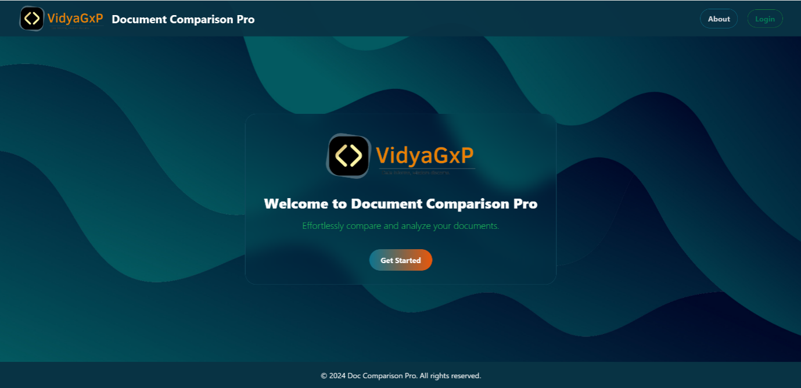

**3.1 Logging In**

Once the users have valid credentials of the software via a web browser:

1. Enter your **username** and **password** on the login page.
2. Click **Login** to access your personalized dashboard.

**Note**: For first-time users, credentials will be sent via email by the system administrator.



**3.2 Forgot Password**

If you have forgotten your password:

1. Click **Forgot Password** on the login screen.
2. Enter your registered email address.
3. Check your inbox for the password reset link.
4. Follow the instructions to reset your password.

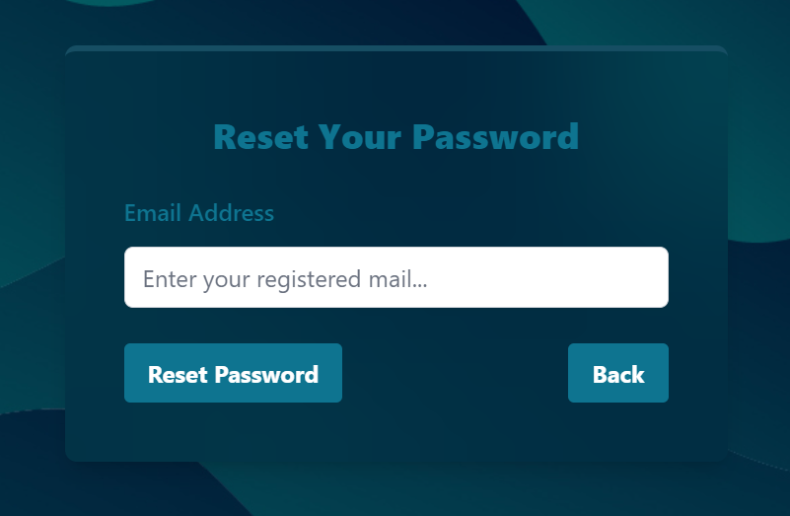

**4. User Roles and Permissions**

**4.1 Overview**

**Document Comparison Pro** allows administrators to assign various roles to users, with specific permissions controlling their level of access. The system supports role-based permissions, ensuring document security and user accountability.

**4.2 User Roles**

* **Administrator**: Full control over the system, including user management, permission assignment, and document uploads.
* **Editor**: Can upload, edit, and compare documents but has no control over user management.
* **Viewer**: Can view comparison reports but cannot upload or edit documents.

**4.3 Managing Permissions**

Admins can assign the following permissions:

* **Upload Documents**: Allow users to upload new files to the system.
* **Compare Documents**: Allow users to run comparisons between uploaded documents.
* **View Reports**: Allow users to view and download the comparison reports.
* **Manage Users**: Grant the ability to add, edit, or delete users from the system.

To manage permissions:

1. Go to the **User Management** section.
2. Select the user you wish to modify.
3. Assign the desired permissions using the provided checkboxes.

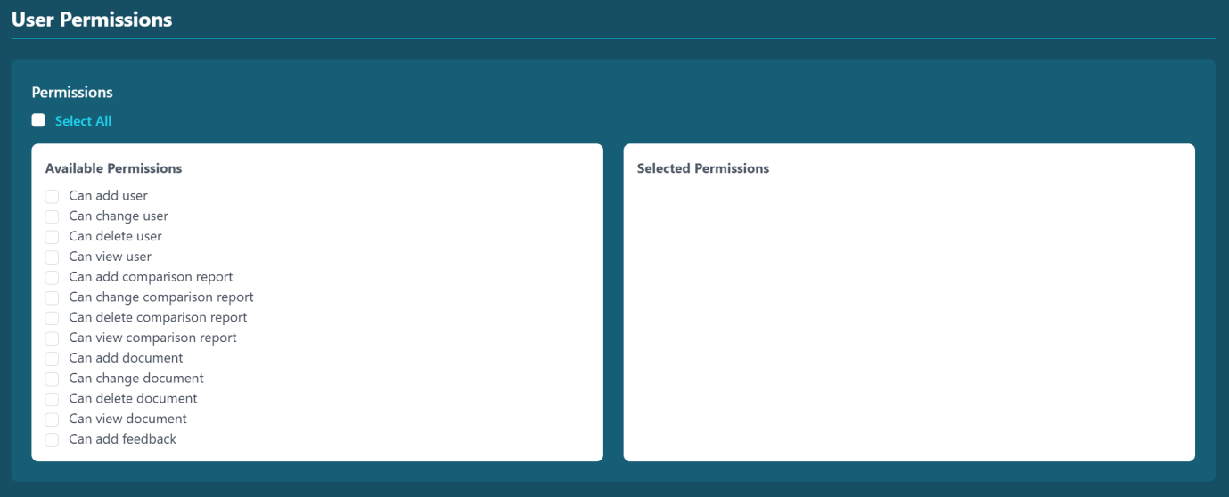

**5. Uploading and Managing Documents**

**5.1 Uploading Files**

The document upload feature allows users to submit multiple files for comparison. Users can upload documents in bulk or individually.

**Step-by-Step Process:**

1. From the dashboard, navigate to the S**tart Comparison** section.
2. Click **Browse Files** or drag-and-drop your files into the upload area.
3. Multiple files can be uploaded at once, but ensure that each file is under the maximum size limit (default: 25MB per file).
4. Click **Upload** to submit the files for processing.
5. After successful upload, the documents will appear in the **Document Library** for comparison.

**5.2 Supported File Formats**

* PDF (.pdf)
* Microsoft Word (.docx)
* Text Files (.txt)

*Note*: Ensure files are properly formatted and not corrupted before uploading.

**5.3 Document Validation**

During the upload process, the system automatically checks:

* File format (supported formats only).
* File size limits.
* Document integrity (ensuring no errors during the comparison).

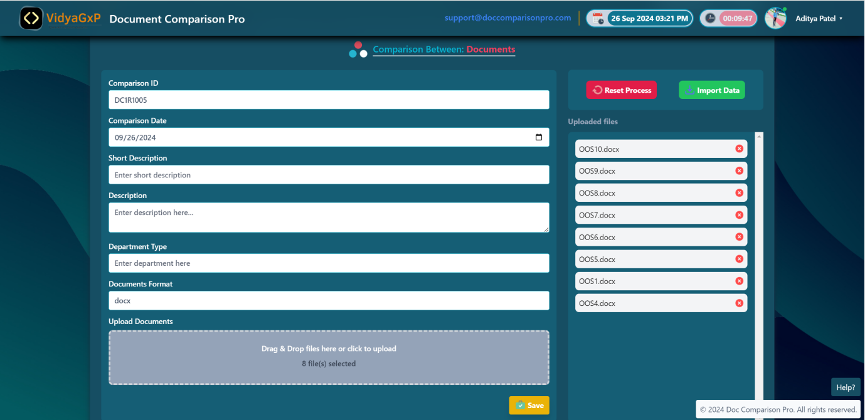

**6. Performing Document Comparisons**

**6.1 Comparing Documents**

Users can compare two or more documents at once to identify differences. The system offers flexible comparison options.

**Step-by-Step Process:**

1. Go to the **Start Comparison** section from the dashboard.
2. Select the documents you want to compare by checking the boxes next to each document.
3. Choose the **Comparison Type**:
   * **Content Comparison**: Compares the text and structure of the documents.
   * **Layout Comparison**: Identifies changes in formatting and layout (e.g., headers, tables, footnotes).
4. Click **Compare Now**. The system will generate a detailed report.
5. View the report immediately on the dashboard or download it as a PDF.

**6.2 Report Generation**

Once the comparison is complete, a report is automatically generated with the following features:

* **Color-coded differences**:
  + **Red**: Removed text or sections.
  + **Blue**: Modified or changed text.
  + **Green**: Added text or sections.
* **Interactive Comparison Viewer**: Allows users to scroll through documents side-by-side for real-time comparison.
* **Downloadable Reports**: Export reports as PDF for record-keeping or sharing.

**6.3 Comparing Multiple Versions**

You can compare more than two versions of the same document to track changes over time. The system will display cumulative differences across the versions.

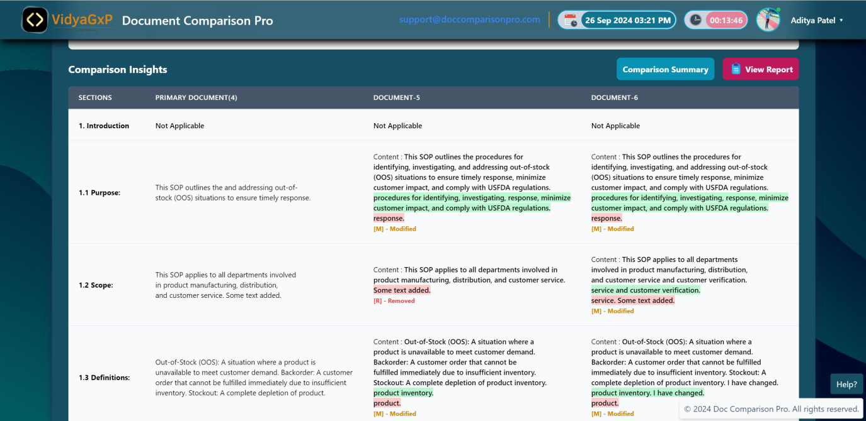

**7. Viewing and Managing Reports**

**7.1 Accessing Comparison Reports**

All reports generated from document comparisons are accessible from the **Comparison Reports** section. Users can:

* View the report in real-time.
* Download reports in PDF format for offline review.

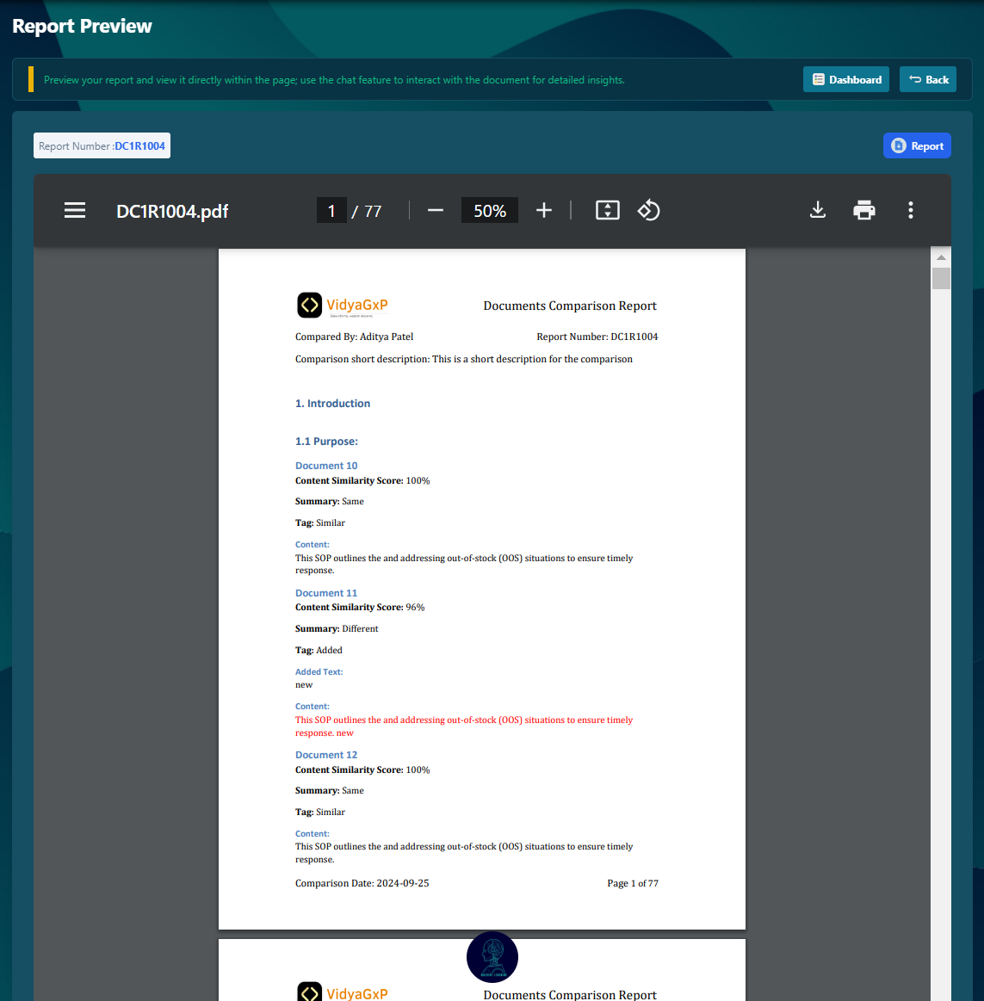

**7.2 Sharing Reports**

Users with appropriate permissions can share reports via email or export the reports as PDF files for distribution.

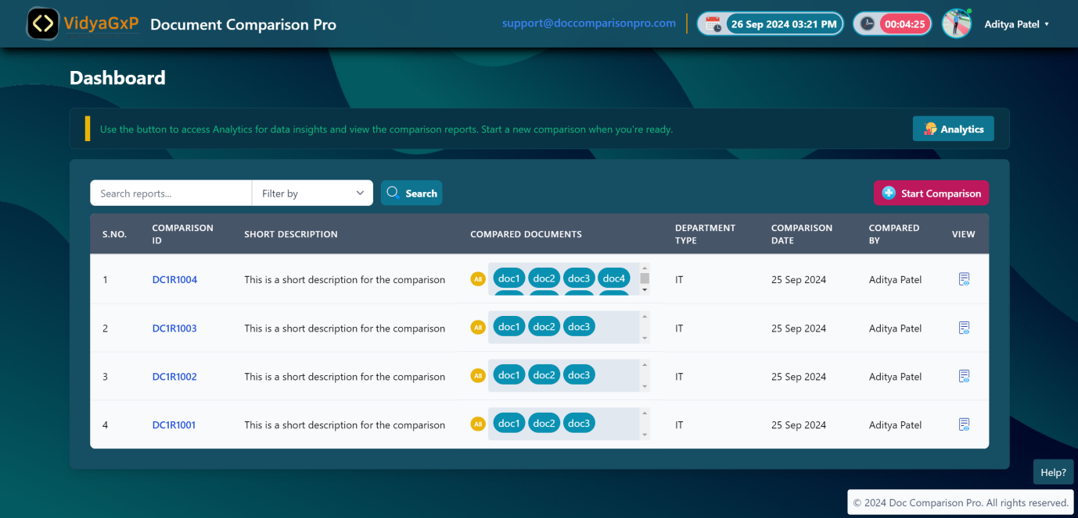

**8. User Management (Admin Only)**

**8.1 Adding New Users**

To add new users:

1. Go to the **User Management** section.
2. Click **Add New User**.
3. Fill in user details such as name, email, and role.
4. Assign permissions based on the role.
5. Click **Save** to create the new user.

**8.2 Editing User Permissions**

1. Go to the **User Management** section.
2. Select the user whose permissions you want to modify.
3. Adjust permissions as needed.
4. Click **Save** to apply changes.

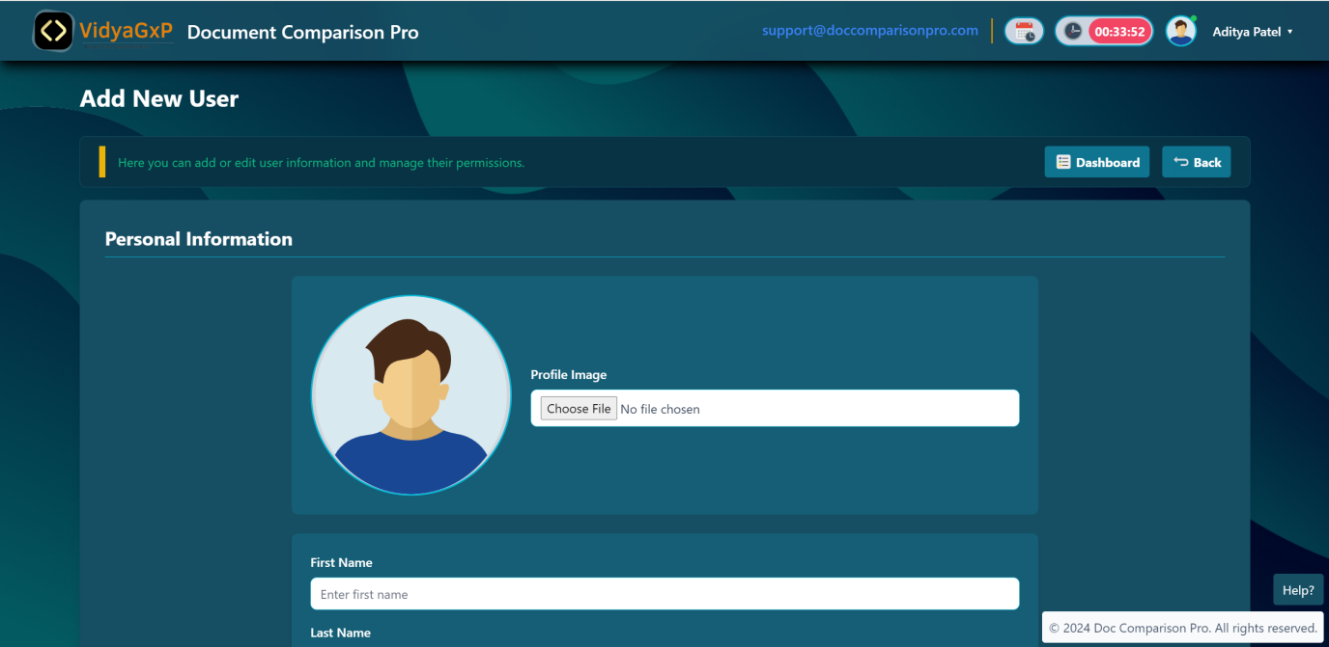

**9. Troubleshooting and Support**

**9.1 Common Issues**

**Q: I can’t upload my document. What could be the issue?**  
A: Ensure that the file format is supported and the file size does not exceed the system limit (default: 25MB per file). Also, verify that your internet connection is stable.

**Q: I’m unable to compare documents. What should I do?**  
A: Check if you have the required permissions to perform document comparisons. If the issue persists, contact your system administrator.

**Q: How do I reset my password?**  
A: Click **Forgot Password** on the login screen and follow the instructions sent to your email.

**9.2 Technical Support**

For any technical issues or further assistance, contact our support team:

* **Email**: support@documentcomparisonpro.com
* **Phone**: +1-800-123-4567
* **Hours**: Monday to Friday, 9:00 AM - 6:00 PM (EST)

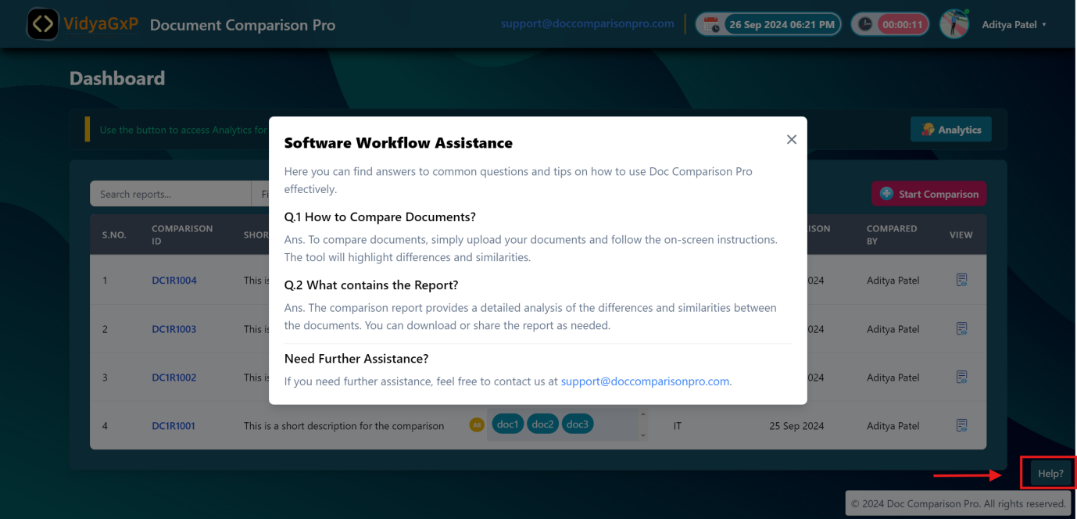

**10. Additional Features**

**10.1 Version History**

* Track document versions over time.
* Compare any version with the current document for precise tracking of changes.

**10.2 Customizable Reporting**

* Export reports in various formats (PDF, CSV, etc.).
* Customize reports based on specific needs or requirements (legal, editorial, etc.).